**Data Communication**

**Practical File**

**(CEECC12)**



Submitted By: -

**Index**

|  |  |  |
| --- | --- | --- |
| **S.N.** | **Experiment** | **Page No** |
| 1 | Introduction to MATLAB |  |
| 2 | Plot Uniform Distribution and calculate its mean and variance |  |
| 3 | Plot Gaussian Distribution and calculate its mean and variance |  |
| 4 | Calculate signal to quantization noise ratio of uniform distribution. Plot R vs Quantization levels |  |
| 5 | Compute the Signal to quantization Noise ratio of Non-Uniform Quantization. Plot SNQR versus Quantization levels. |  |

**Experiment 1**

Introduction to MATLAB

**Objective**:-

a) Matrix Computation

b. To Plot Sine Wave of frequency 200 Hz.

c. To plot a pulse of width 10.

d. Plot the spectrum (Amplitude and phase) 0f the pulse generated in 3.

a)

**Code and output** :

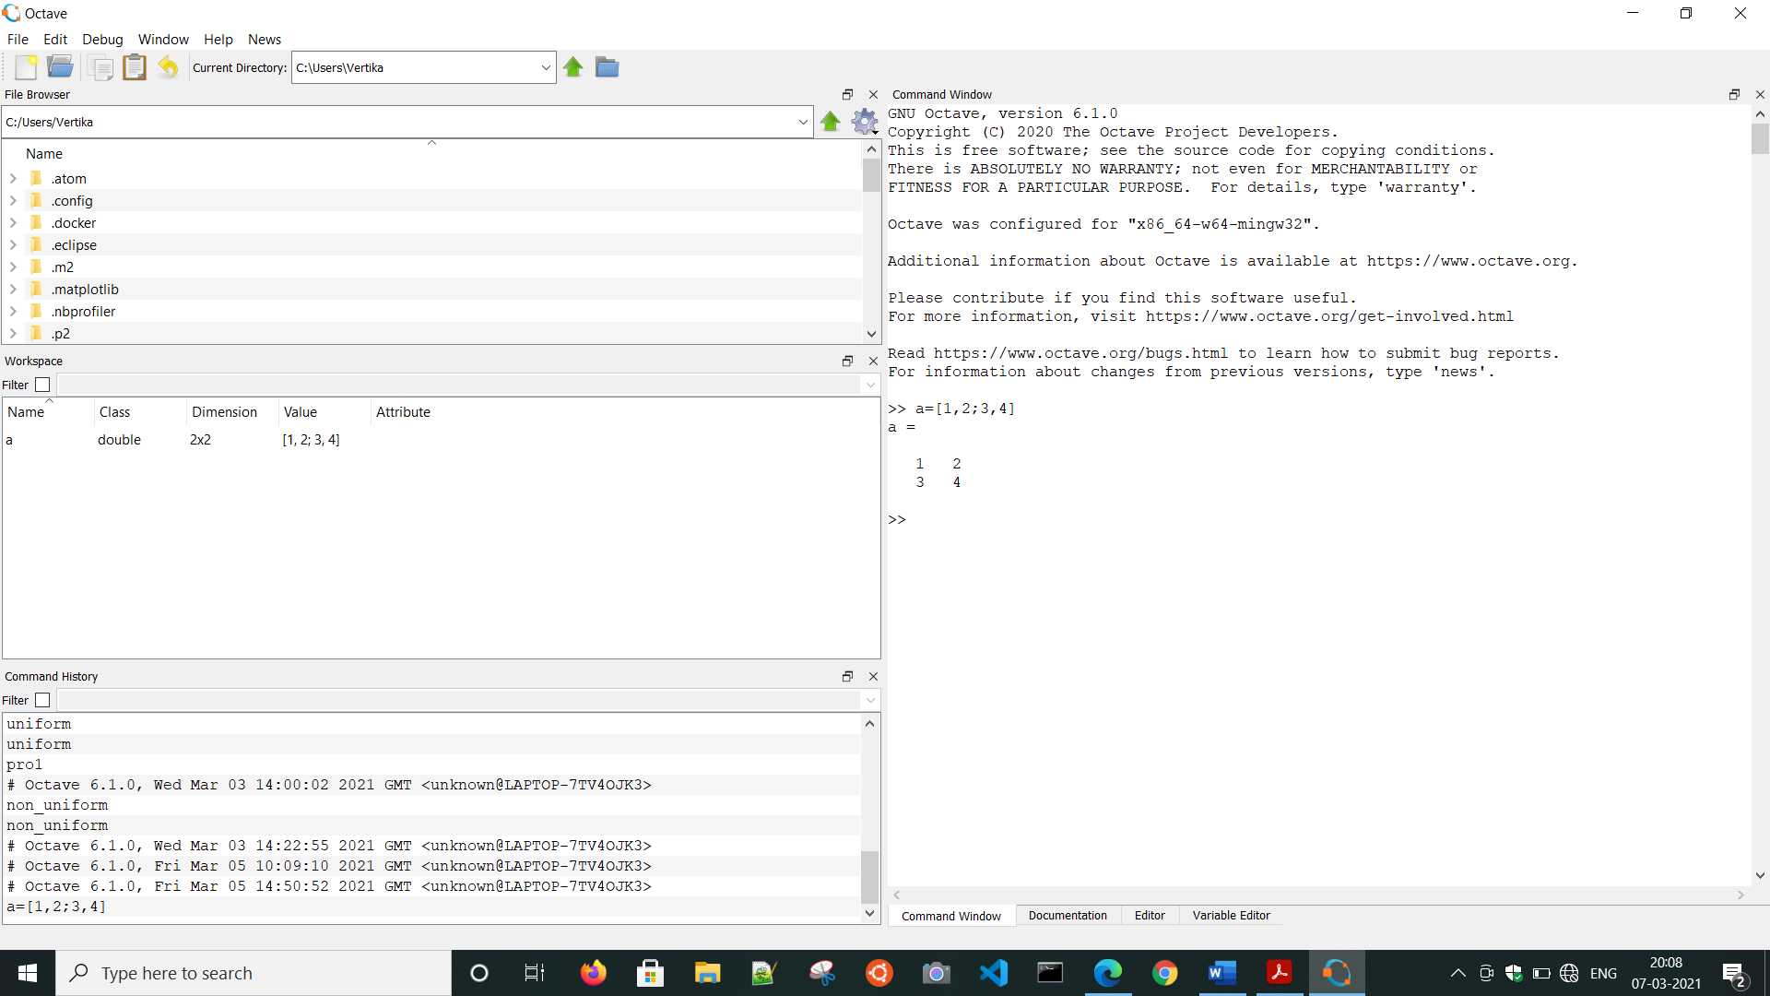

b)

**Code:**

t=0:0.00025:0.01;

y=sin(2*pi*200*t);

plot(t,y);

**Output**:

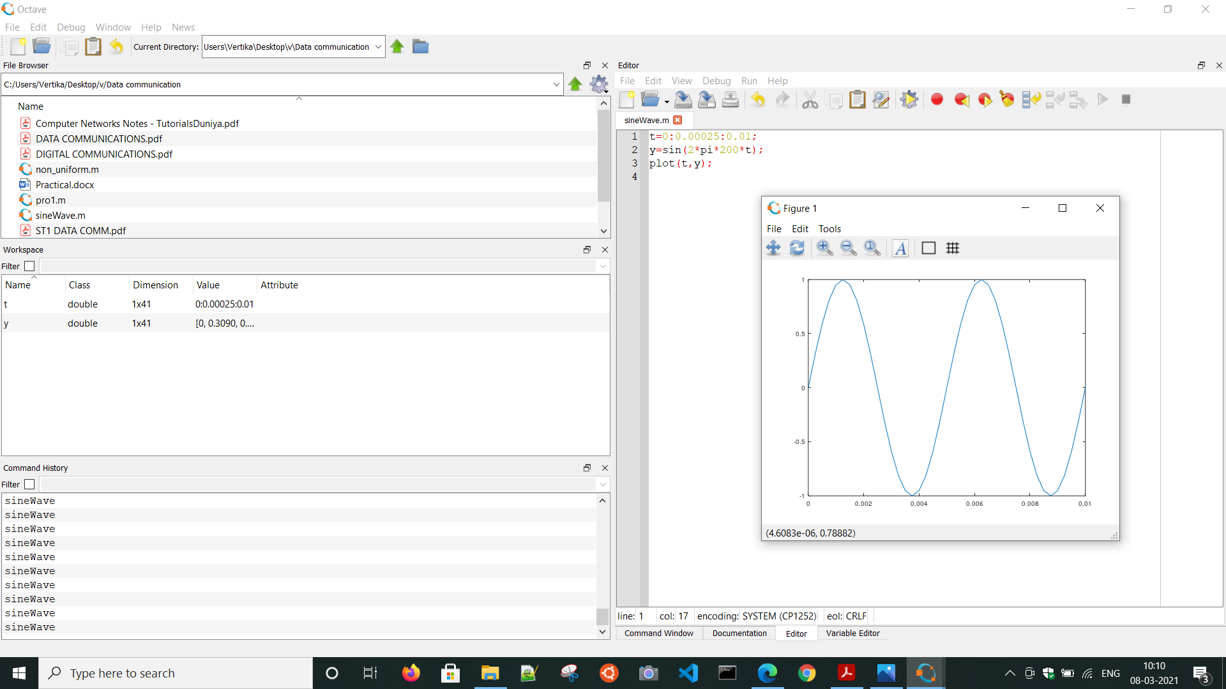

c)

**Code**:-

t=-10:1/1000:10;

y=rectpuls(t, 10);

plot(t, y);

axis([-10.5 10.5 -0.5 1.5]);

title('Pulse of width 10');

**Output**:-

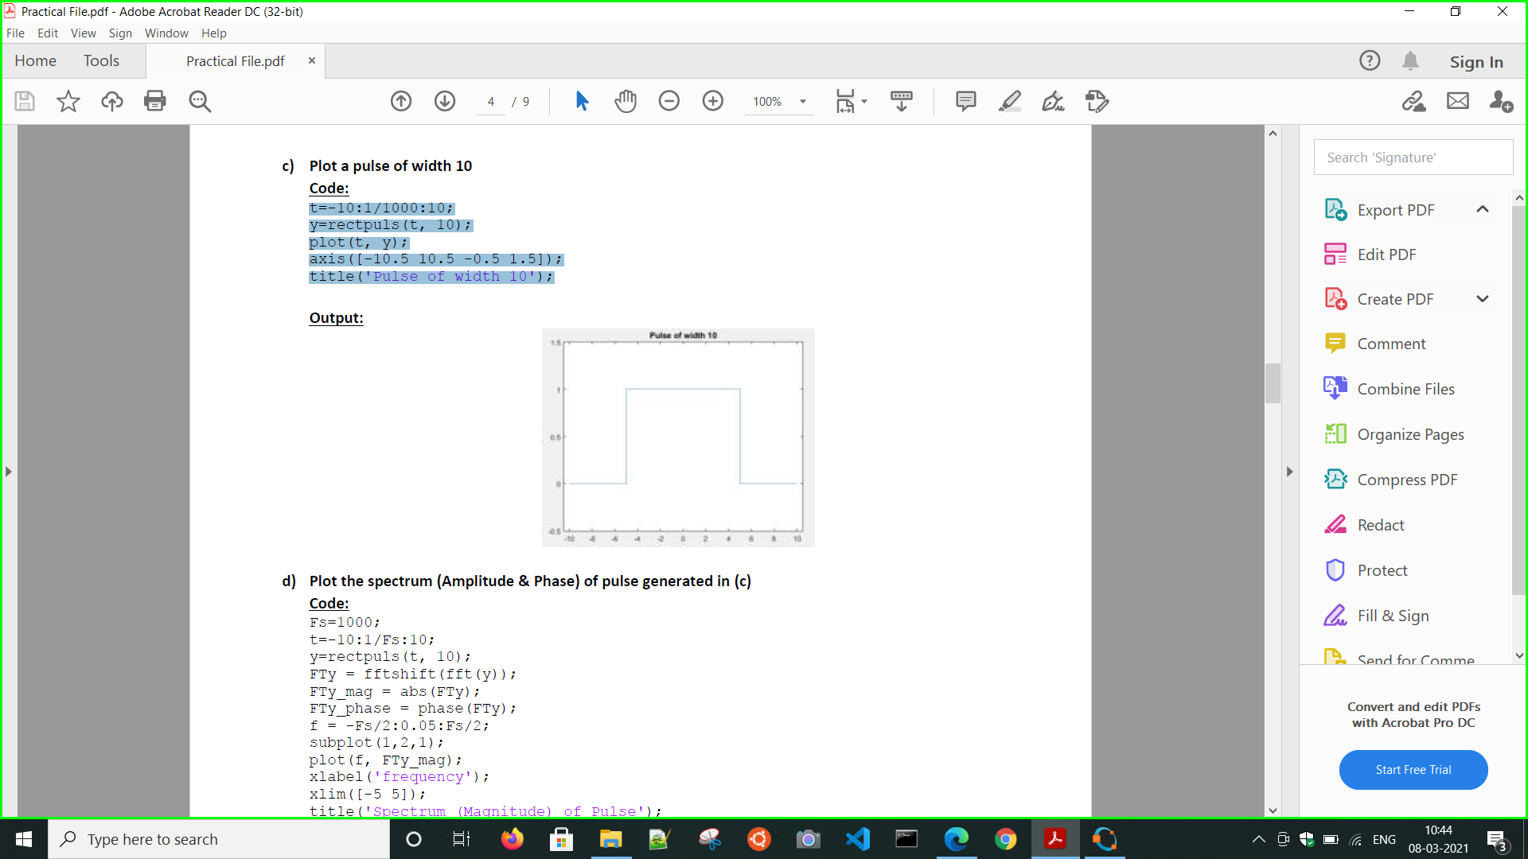

d)

**Code**:-

Fs=1000;

t=-10:1/Fs:10;

y=rectpuls(t, 10);

FTy = fftshift(fft(y));

FTy_mag = abs(FTy);

FTy_phase = phase(FTy);

f = -Fs/2:0.05:Fs/2;

subplot(1,2,1);

plot(f, FTy_mag);

xlabel('frequency');

xlim([-5 5]);

title('Spectrum (Magnitude) of Pulse');

subplot(1,2,2);

plot(f, FTy_phase);

xlabel('frequency');

xlim([-1 1]);

title('Spectrum (Phase) of Pulse');

**Output**:

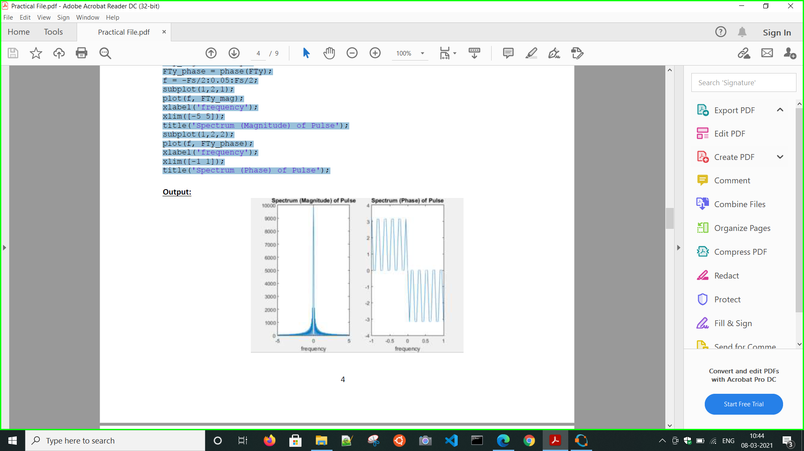

**Experiment 2.**

**Objective:**- Uniform random number and plot its density function. Find its mean and variance.

Code:-

a=1;

b=5;

N=10000;

x=a+(b-a).*rand(1,N);

hist(x);

disp(mean(x));

disp(var(x));

**Output**:-

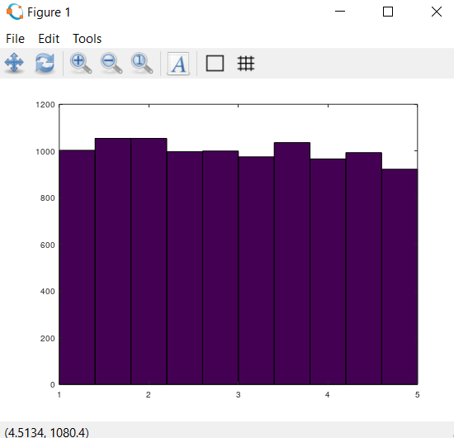

**Experiment 3.**

**Objective**:- Generate Gaussian distributed random number and plot its density function. Find

its mean and variance.

**Code**:-

clc;

clear all;

mat=randn(1,10000);

[p,x]=hist(mat);

plot(x,p/sum(p))

%mean

sum1=0;

for i=1:10000

sum1=sum1+mat(i);

end

mean=sum1/10000

sum2=0;

for i=1:10000

sum2=sum2+(mat(i)-mean)^2;

end

var=sum2/1000

**Output**:-

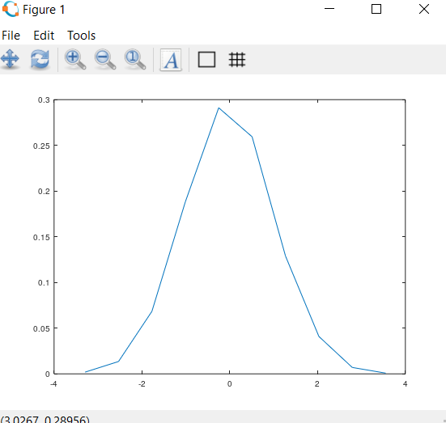

**Experiment 4.**

**Objective:**- Compute the Signal to quantization Noise ratio of Uniform Quantization. Plot SNQR

versus Quantization levels.

**Code**:-

clc;

clear all;

A=6;

Sampled_sgl=2*A*rand(1,200)-A;

signal_pow=(norm(Sampled_sgl)^2)/length(Sampled_sgl);

subplot(2,1,1);

plot(Sampled_sgl);

title('signal');

xlabel('time');

ylabel('Amplitude');

ylim([-6,6]);

noise_pow=zeros(1,200);

SNQR=zeros(1,200);

for j=1:200 %Number of levels

levels=j;

step_size=2*A/levels;

noise_pow(j)=(step_size^2)/12;

SNQR(j)=signal_pow/noise_pow(j);

end

subplot(2,1,2);

plot(SNQR);

**Output**:

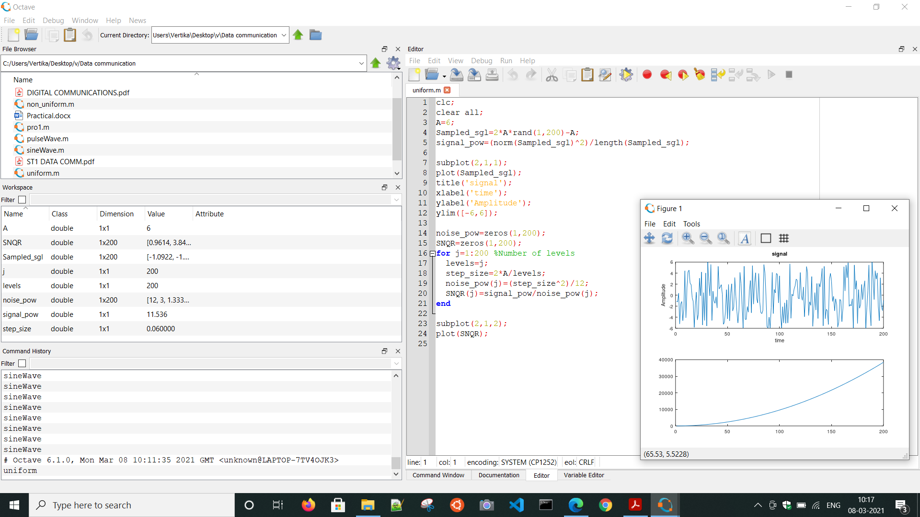

**Experiment 5**

**Objective**:- Compute the Signal to quantization Noise ratio of Non-Uniform Quantization. Plot

SNQR versus Quantization levels.

Code:-

clc;

clear all;

A=5;

Sampled_sgl=2*A*rand(1,100)-A;

%MU-law companding

u=255; %compression constant

for i=1:100

if Sampled_sgl(i)>0

companded_sgl(i)=A*log(1+u*(Sampled_sgl(i)/A))/log(1+u);

else

companded_sgl(i)=A*log(1-u*(Sampled_sgl(i)/A))/log(1+u);

endif

end

sgl_pow=(norm(companded_sgl)^2)/length(companded_sgl);

subplot(2,1,1);

plot(companded_sgl);

noise_pow=zeros(1,200);

SNQR=zeros(1,200);

for j=1:200 %Number of levels

levels=j;

step_size=2*A/levels;

noise_pow(j)=(step_size^2)/12;

SNQR(j)=sgl_pow/noise_pow(j);

end

subplot(2,1,2);

plot(SNQR);

**Output**:

